**Masjid Al-Nur School Application Form: Start 06/17/2023 - End 08/17/2023**

1. **Name Of Student:**

I

Date Of Birth: Circle the Gender: Male /

1. **Name Of Student:**

I

Date Of Birth: Circle the Gender: Male /

1. **Name Of Student:**

I

Date Of Birth: Circle the Gender: Male /

1. **Name Of Student:**

I

Date Of Birth: Circle the Gender: Male /

Female Female Female

Female

1. **Name Of Student:**

Date Of Birth: Parent/Guardian Name:

I Circle the Gender: Male /

Female

|  |  |  |
| --- | --- | --- |
| **Home Address:** |  | **phone:** |
| **City:** | **Sate:** | **Zip code:** |
| **Relationship :** | **Email:** |  |
| **Current Employer:** |  | **Occupation:** |

Work address:

City:

Second Parent/Guardian Name: Relationship :

Languages Spoken of Home:

Sate: phone:

phone Zip code:

Email:

Authorization: I authorization the verification of the information provided on this form and I acknowledge that I will be liable to pay the school tuition fees monthly.

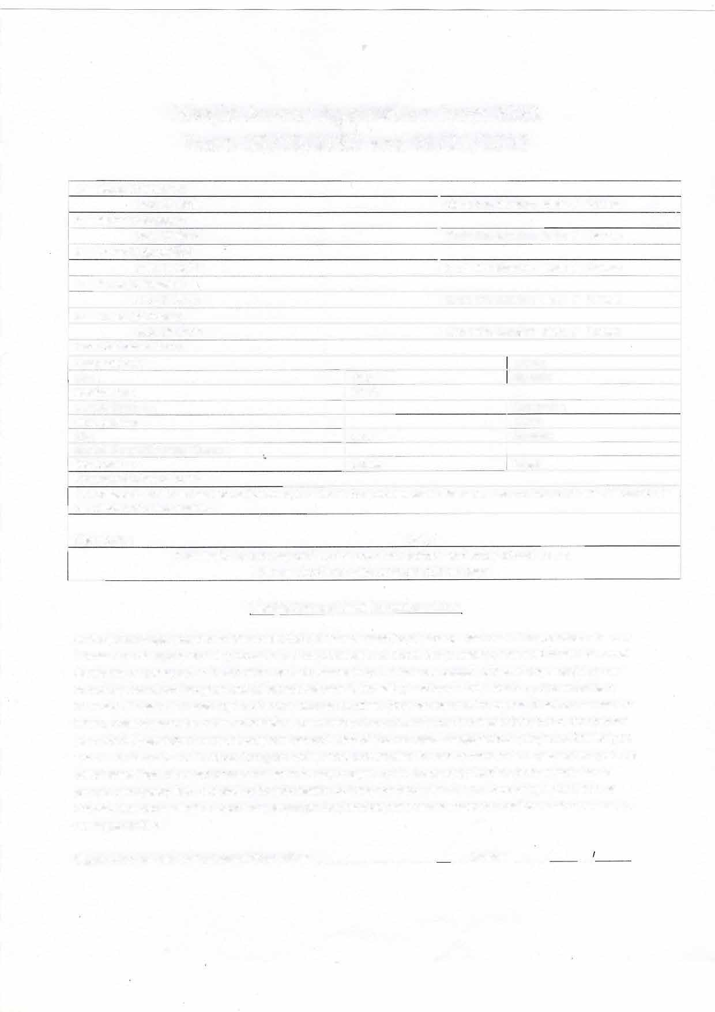

**Signature: Date:**

**P.S Masjid is not responsible for your kids before and after school hours. Please drop and pick up your kids on time**

**Masjid An-nur Liability waiver form**

As the parent/legal guardian of the student(s) children (s) mentioned above, I assume full responsibility for any injuries and damage which may occur to he / she them on in or about the premises of the said masjid or school

/program ,or arising out of its activities, and do hereby fully and forever release and discharge masjid an-nur, its trustees its school/program and all associated with it, including teachers, administrators , and volunteers from any all claim ,demands rights of action, allergic reactions (food or seasonal) or causes of actions present or future, whether same be know, anticipated, or unanticipated ,resulting from from or arising out of the student

(s) children(S) participation in the program and activities of the aforesaid masjid/school/programs. Similarly no one at masjid an-nur or its school/program will be held accountable for loss or damage to any valuables (such as cell phones, iPod, other electronics and jewelry etc) brought by the student(s) .I further grant permission to provide emergency first -aid and/or hospitalization to the student(s) children (s)in case of injury or illness as deemed appropriate by the school or a physician .any medical expenses incurred for medical treatment shall be my responsibility.

**Signature of parents/Legal Guardian**  **_ Date:**  **/ _.**